A compact for biomarker development in South Africa
Jul 25th, 2013
by Reinhard Hiller.

Recently, the CPGR joined The Biomarkers Consortium.
The ‘Biomarkers Consortium’, or ‘Consortium’, is a public-private scientific partnership between the Foundation for the National Institutes of Health (FNIH), the National Institutes of Health (NIH), the Food and Drug Administration (FDA), the Centres for Medicare & Medicaid Services (CMS), members of the pharmaceutical, biotechnology, diagnostics, and medical device industries, members of non-profit organizations, and academicians.
In a nutshell, the aim of the Consortium is to stimulate biomarker development. Amongst others, this is accomplished by way of creating pre-competitive partnerships, bringing together stakeholders from different stages of the biomarker development chain who are interested in progressing promising biomarker developments from bench to bedside. In other words, we are dealing with organisations that are fully cognizant of the corresponding challenges and risks, and are committed to finding new avenues for effective biomarker development.
Our objective from being a member of The Biomarkers Consortium is as follows:
- We want to learn as much as we can from being involved in designing and running these biomarker development projects, in the interest of developing outstanding knowledge in what it means to translate biomarkers from bench to bedside.
- We want to use what we already know of the process and what we learn from participating in the Consortium (point 1) to proactively create projects originating from South Africa and consequently propose these to the Consortium for consideration. The benefit of this approach is that we are dealing with a critical mass of individuals and organisations who (i) understand the development process and (ii) may have an interest in commercialising the output(s). The corresponding evaluation and planning goes way beyond the basic science, it effectively maps a path to commercialisation, and therefore towards the creation of socio-economic value.
- We want to translate the opportunities (i.e. the biomarker projects) we are being exposed into the local community, even if our eventual involvement would be marginal. This is in the interest of creating a local activity base dealing with biomarker projects. This will benefit CPGR on the long-term and has great potential for spin-off activities that can add value to CPGR and other local stakeholders.
The Consortium has a focus on the following biomedical areas: Cancer, Inflammation & Immunity, Metabolic Disorders, and Neuroscience. Membership creates opportunities for assessing pipeline projects falling in these areas on the basis of strategic fit with individual member goals and objectives. Typically, these projects are presented in the form of a prospectus for consideration by individual members.
Project prospectus: Cancer, inflammation & immunity, and metabolic disorders
The projects included in the most recent prospectus fall into the following categories (Table 1): cancer, inflammation and immunity, and metabolic disorders. The USD figures provided below are current estimates of the costs required to turn around these projects. These are stage-specific costs, not the full costs required for developing these biomarker based tests into market-ready products.
Table 1: Summary of projects
Area | Project
Cancer | - Clinical validation of novel technologies for evaluating circulating tumour cells  - Evaluation of minimal residual disease – meta-analysis, education and standards
Inflammation & immunity | - TSPO PET imaging in Rheumatoid Arthritis  - Validation of biomarkers of treatment response in Rheumatoid Arthritis  - Biomarkers of lung function decline in COPD
Metabolic disorders | - Outcome measures for Sarcopenia  - Cardiac troponin biomarkers
At present, we have projects under consideration that fall into the ‘approved concept proposal’ stage, as per The Biomarker Consortium’s stage-gated project prioritisation process (stage 2, Figure 1). At this stage, the Consortium is gauging interest from a variety of stakeholders into supporting any of these projects. Depending on the level of demand, and the extent of commitment, individual projects will then move into the full project plan development phase (stage 3, Figure 1).
Figure 1: Biomarker project prioritisation process
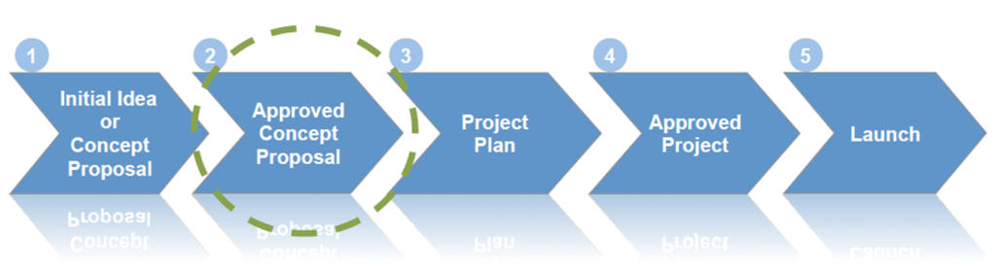
Being a member of the organisation entitles us to consider these opportunities from the following perspectives:
- The relevance of these proposals to our internal priorities;
- Our interest in funding and participating on the multi-stakeholder project teams for any or all of these proposals in 2013 or 2014.
Opportunity for creating a ‘Biomarker Development Compact’ in South Africa
Against the backdrop of our involvement with the Consortium, we are exploring the opportunity for creating a local ‘Biomarker Development Compact’, by way of bringing together a group of individuals and organisations who have a strong interest in biomarker development. Our intention is also to attract interest from funders/financiers of such projects (public or private). Ideally, we want to assemble a diversity of stakeholders, from basic science to business, enabling us to tackle the challenges and opportunities in biomarker development effectively.
We’d like to use this as an opportunity to strengthen the local knowledge base related to biomarker development, one of the most promising areas of interest in biomedical research at present. The field is fraught with complexities, ito science, project design & management, financing, regulatory environment, and business. Presumably, no single organisation in South Africa is going to have all the relevant knowledge (after all, this is why the Consortium exists); but, we strongly believe that there is a critical mass of knowledge locally, if only dispersed. Our intention is to try to and bring this knowledge together, so that we can leverage it more effectively. Working with The Biomarkers Consortium is exciting because it helps us to view biomarker projects through a ‘Translational lens’.
Invitation to join the compact and explore biomarker project opportunities
Innovation in the life and biomedical sciences is often hampered because stakeholders who are positioned in different spheres of the innovation continuum are not effectively exchanging relevant information. As a consequence, opportunities are not seen, knowledge is not shared, risk is not understood, decisions are not being made, and socio-economic value is not made, and even destroyed. Creating a stakeholder compact that shares a common vision and purpose in this regard is one way to overcome current shortcomings in biomarker development.
This is a cordial invitation to exchange ideas and to invite interests from a diversity of stakeholders.
Individuals interested in obtaining more information about individual projects in the prospectus, or to discuss new project ideas for possible consideration by the Consortium, can contact us at reinhard.hiller@cpgr.org.za.

